CS 255 System Design Document Template

UML Diagrams

UML Use Case Diagram
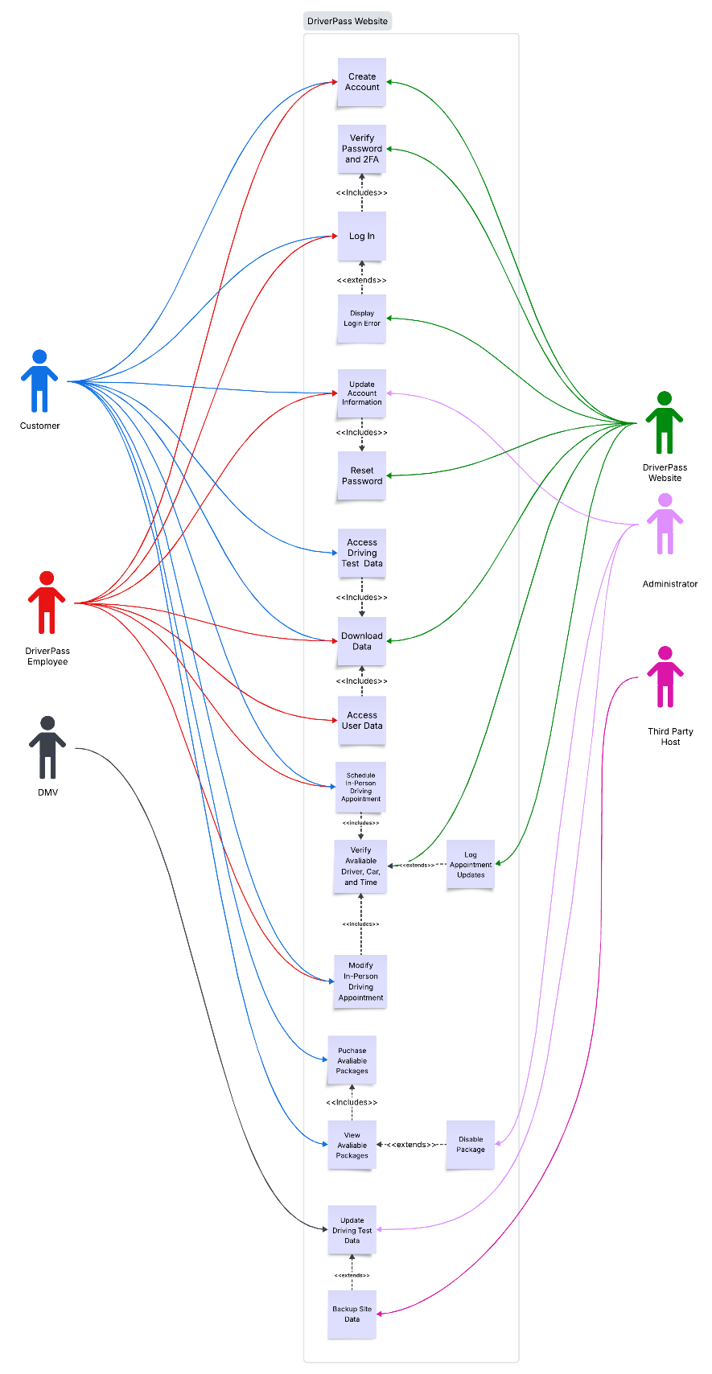

UML Activity Diagrams
User Registration Activity Diagram:
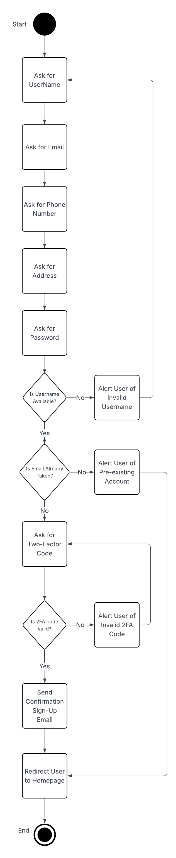
User Package Purchasing Activity Diagram:
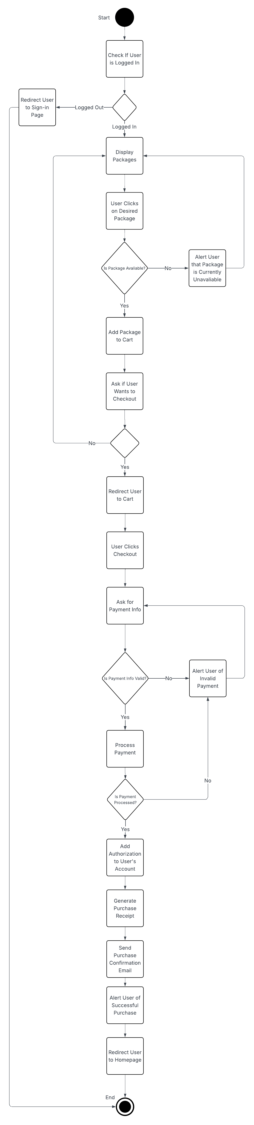

UML Sequence Diagram
User Registration Sequence Diagram:
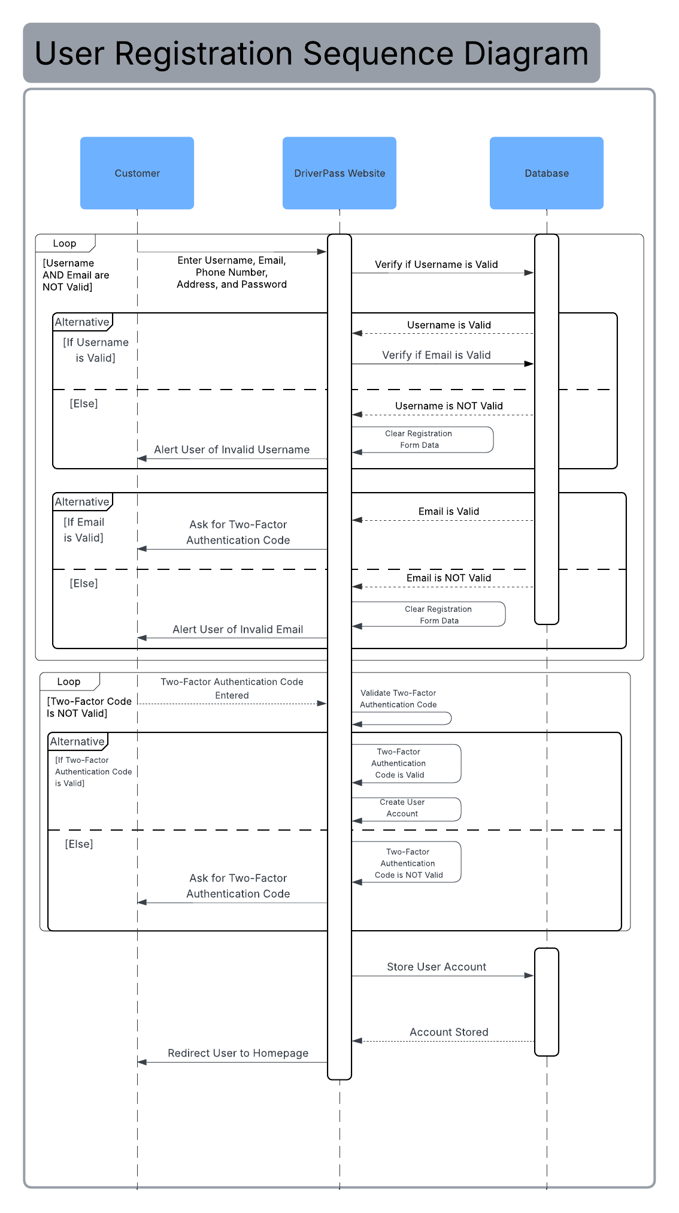
UML Class Diagram
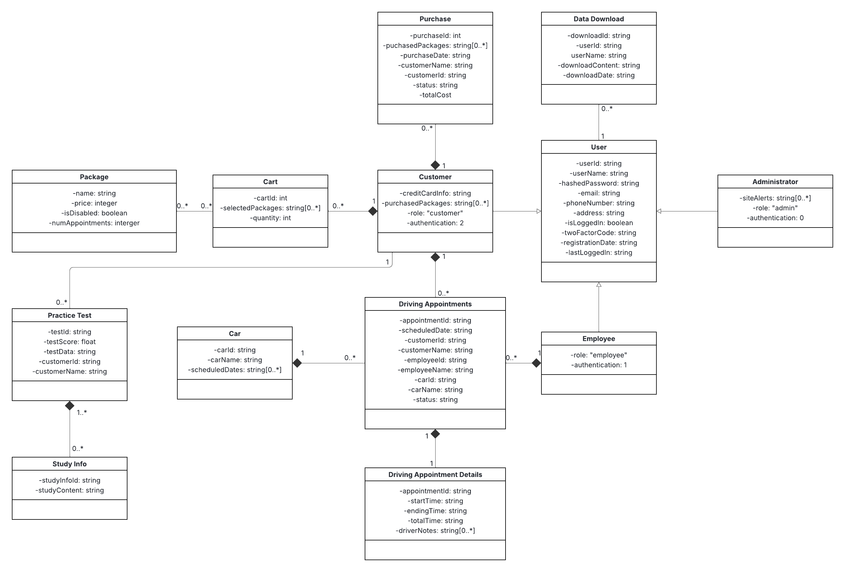

Technical Requirements
- Hardware
  - Dedicate server for hosting the website and its associated database
  - A constant internet connection
  - Enough storage to house the data generated by users and the website
  - Devices for users to access the website, such as desktop computers or mobile devices
- Software
  - A server operating system, such as Linux
  - An SQL database management system, such as PostgreSQL
  - Security software for securing the server from malicious and unauthorized users
  - Any web browser to access the site
- Tools
  - A Backup software tool for backing up all user data and site data
  - A HTTPS hosting software tool to allow the website to be hosted from the dedicated server
  - A two-factor authenticator software tool for validating two-factor authentication codes
- Infrastructure
  - The server will be maintained and hosted by a third party
  - The backing up of the server will be overseen by the third-party host

